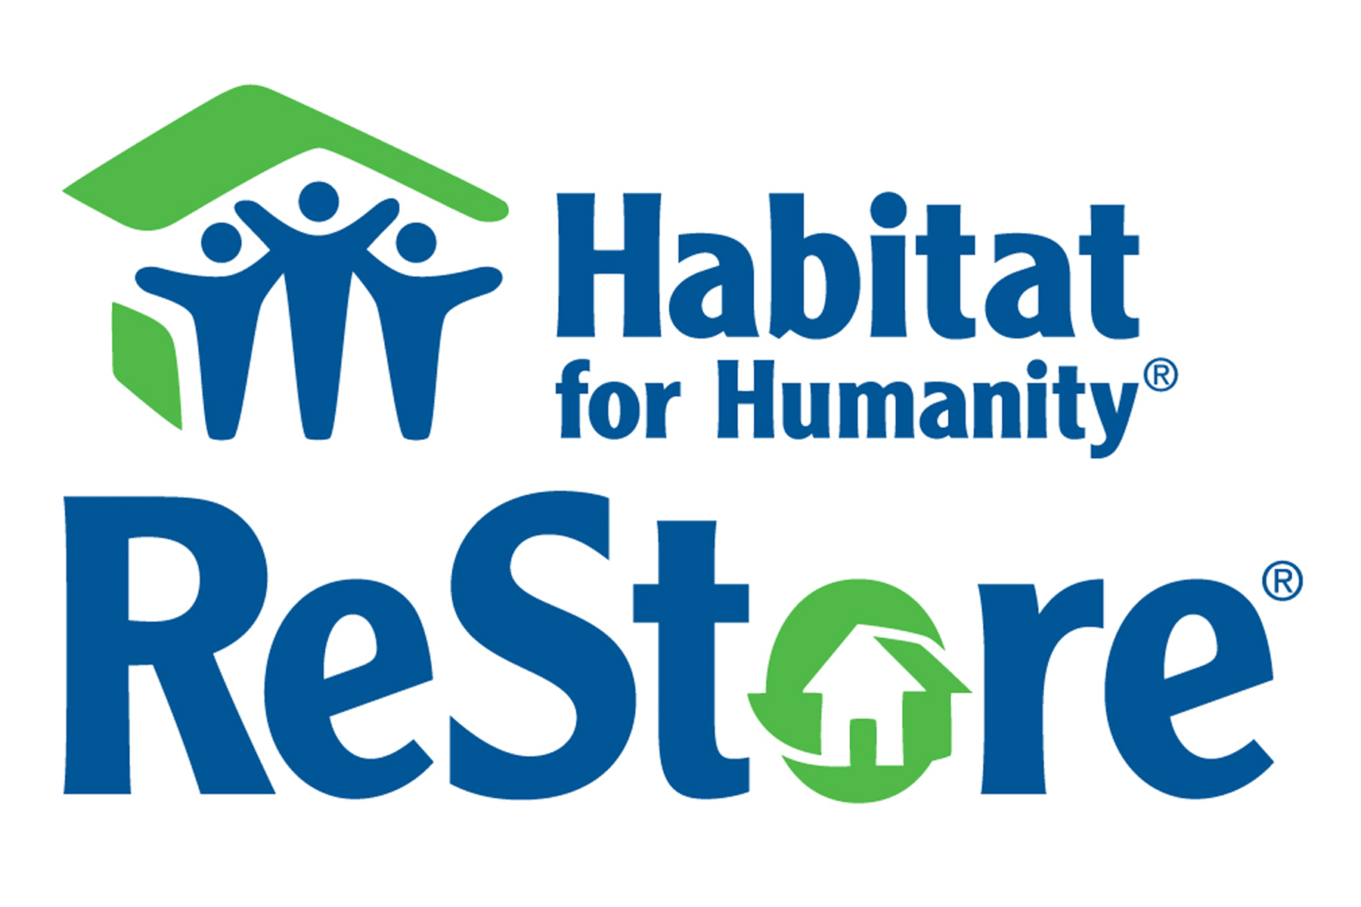
NASMM to Host Online Charity Auction to Benefit Habitat for Humanity
NASMM is pleased to announce we will once again host an online charity auction in conjunction with our 2016 Annual Conference. The proceeds from this year’s auction will benefit our philanthropic partner, Habitat for Humanity Restores.
Habitat for Humanity ReStores are nonprofit home improvement stores and donation centers that sell new and gently used furniture, appliances, home accessories, building materials and more to the public at a fraction of the retail price. ReStores are independently owned and operated by local Habitat for Humanity organizations. Proceeds are used to build homes, community, and hope locally and around the world.
The auction will be hosted by our Industry partner MaxSold, and provides you with a unique opportunity to experience, first-hand, an online auction as both a bidder and a potentially as a donor. This experience will allow you to evaluate the MaxSold online auction platform to determine if their service is a resource you would like to offer your clients.
The bidding for the charity online auction will begin on Monday, February 15 at 5pm ET and will close on Saturday, February 27 at 9:30 am ET. Bidding will be open to all NASMM members, whether you are attending the conference or not.
To make this auction a success, we need donations for the auction. Gift cards, electronics, free or reduced products and services, training and consulting are just a few of the many items that can be donated for our online auction.
Here are some ideas:
- Use your credit card points to purchase a gift card or item that can be donated.
- Offer a couple of hours of consulting services.
- If you are an author, consider donating a package of several books that a member could purchase and give as gifts to clients
- Join together with other members in your area and pool your resources to contribute items.
- Ask local vendors to make a donation - this way your employees or other members in the area could bid on a gift card to a local shop or restaurant.
Click here to access the NASMM Charity Online Auction Donation form

